**MP Practical- 8**

Name- Siddhesh Dilip Khairnar

Roll No.- 272028

Batch- B2

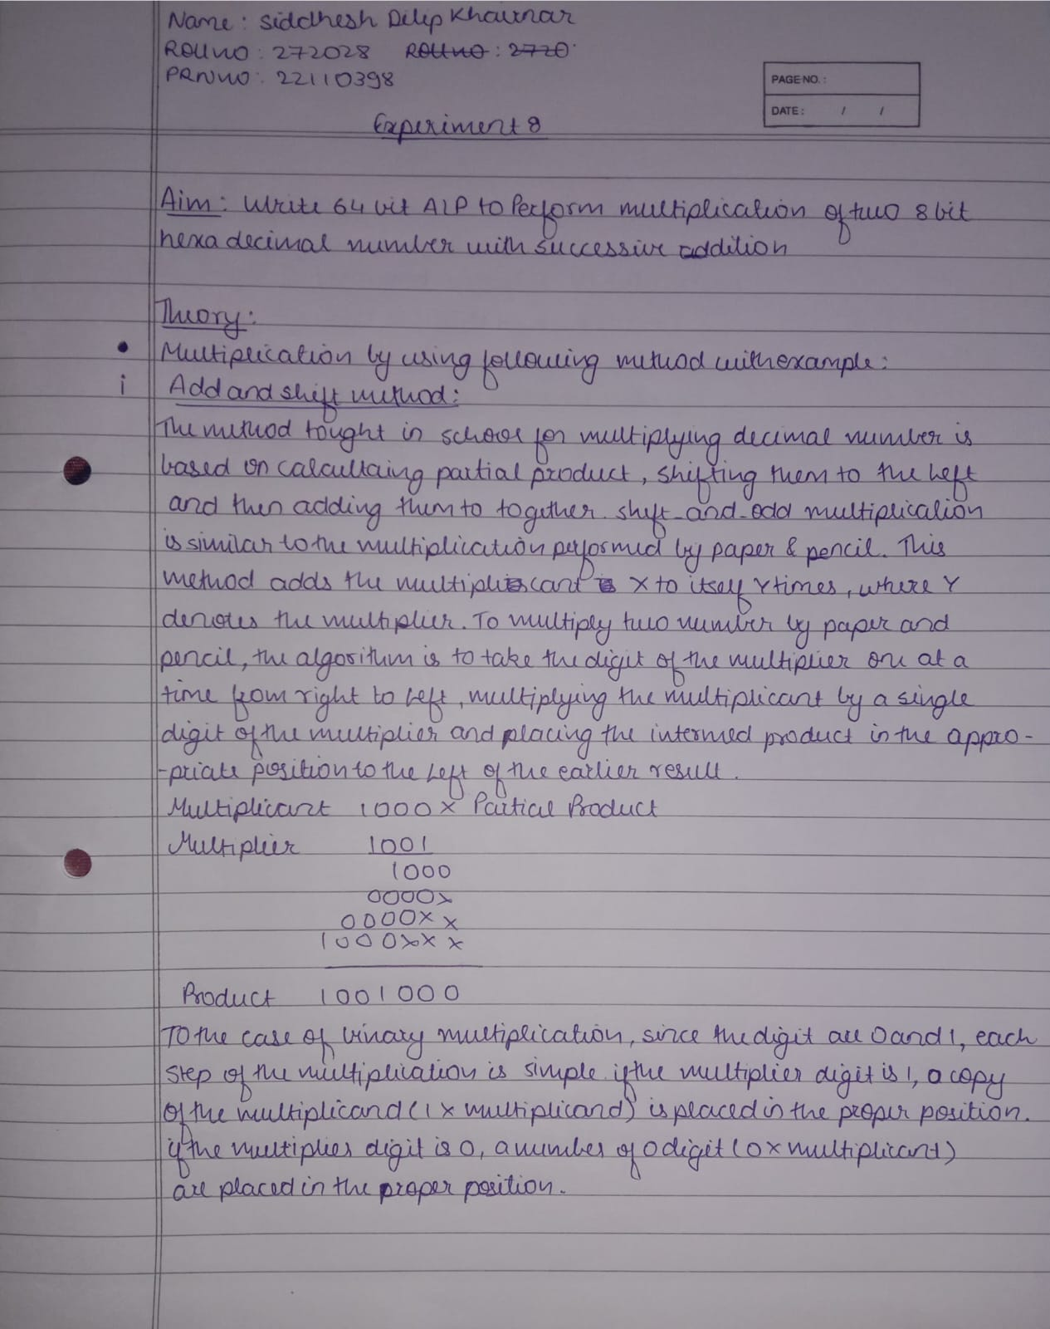

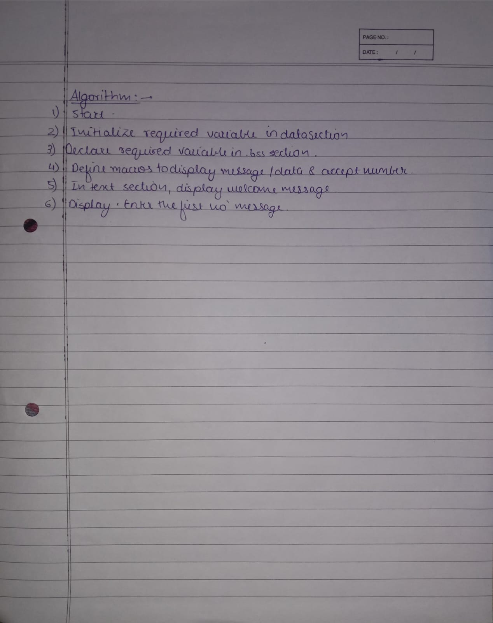

**Code:**

section .data

msg db "ALP to multiply two 8 bit hex numbers",10

msg_len equ $ - msg

opr1 db "multiplicand : "

opr1_len equ $ - opr1

opr2 db 10,"multiplier : "

opr2_len equ $ - opr2

menu db 10,10,13,"1. Successive Addition Method",10

db 13,"2. Add and shift method",10

db 13,"3. Exit",10

db 10,"Enter your choice (1/2/3) : "

menu_len equ $ - menu

alert db 10,"WRONG CHOICE"

alert_len equ $ - alert

res db 10,"The product is : "

res_len equ $ - res

msg_end db 10,"End of ALP"

msg_end_len equ $ - msg_end

section .bss

multiplier resb 1 ;variable after ASCII to Hex

multiplicand resb 1 ;variable after ASCII to Hex

num resb 03 ;variable before ASCII to Hex

result resb 04 ;for display procedure

choice resb 2 ;for choice of user

product resw 1 ;to store the product

%macro IO 4

mov rax,%1

mov rdi,%2

mov rsi,%3

mov rdx,%4

syscall

%endmacro

section .text

global _start

_start:

xor rax,rax

xor rbx,rbx

xor rcx,rcx

xor rdx,rdx

IO 1, 1, msg, msg_len

IO 0 ,0,num,3

IO 1, 1, opr1, opr1_len

IO 1,1,num,2 ;to access the data without enter char

call convert

mov [multiplicand],bl

IO 0 ,0,num,3

IO 1, 1, opr2, opr2_len

IO 1,1,num,2

call convert

mov [multiplier],bl

IO 1, 1, menu, menu_len

IO 0, 0, choice, 2

IO 1, 1, choice, 2

cmp byte[choice],31h

jne case2

call successive_addition

jmp endOfProgram

case2:

cmp byte[choice],32h

jne case3

call add_shift

jmp endOfProgram

case3:

cmp byte[choice],33h

je endOfProgram

IO 1,1,alert,alert_len

endOfProgram:

IO 1,1,msg_end,msg_end_len

mov rax, 60

mov rdi, 0

syscall

convert: ;; for ASCII to Hex conversion

xor rbx,rbx

xor rcx,rcx

xor rax,rax

mov rcx,02

mov rsi,num

up1:

rol bl,04

mov al,[rsi]

cmp al,39h

jbe p1

sub al,07h

jmp p2

p1: sub al,30h

p2: add bl,al ;bl stores the ASCII equivalent(byte) of the multiplicand/multiplier

inc rsi

loop up1

ret

disp: ;for Hex to ASCII conversion

mov rcx,4

mov rdi,result

dup1:

rol bx,4

mov al,bl

and al,0fh

cmp al,09h

jbe p3

add al,07h

jmp p4

p3: add al,30h

p4:mov [rdi],al

inc rdi

loop dup1

IO 1,1,result,4

ret

successive_addition:

xor rcx,rcx

xor rax,rax

mov word[product],0

mov bl,[multiplier]

mov al,[multiplicand]

next:

add [product],ax

dec bl

jnz next

IO 1, 1, res, res_len

mov bx,[product]

call disp

ret

add_shift:

mov word[product],0

xor rbx,rbx

xor rcx,rcx

xor rdx,rdx

xor rax,rax

mov dl,08

mov al,[multiplicand]

mov bl,[multiplier]

p11:

shr bx,01

jnc p

add cx,ax

p:

shl ax,01

dec dl

jnz p11

mov [product],rcx

IO 1,1,res,res_len

mov rbx,[product]

call disp

ret

**Output:**

